- Placement candidate: Disan Buteera
- Report date: 25/02/2021
- Discipline or degree: Youth Justice (Q63)
- Faculty: School of health and social care
- Year of study /level: 2
- Academic year: 2020/21
- Website project family – Kanziira (URLs)/website: http://yourwebsiteprojectfamilyhutu-isrealraceruanda.family
- University /Institution/Establishment: The Open University, England
- Report writing Question:
- Writing a report from the perspective of a student on a placement in a family centre.
- The context:
- Theme: ‘Effectively using learning and positive risk taking to support Children and young people’s wellbeing'
- Report audience: Manager of the family centre
- Report purpose: Submitting a bid for funding
- Source of report materials: KE206 module materials relating to this theme
- Foreword: By the Senior Management; Prince Lubulwa Samuel Kyagera: I am very thankful to have you all at our Website project family -Kanziira. The family offers understanding, learning, play, conversations, entertainments extra. Do not forget to enroll your interest/s. Thank you.
- Introduction
- The purpose of the Report – Website project family - Kanziira
- The purpose of the report is to submit a bid for funding that has to be administered by Website project family – Kanzira manager.
- In a Spotlight, an evaluation for effectively use learning and positive risk taking to support Children and young people’s wellbeing.
- The report is going to cite two names of children who have been supported by a family centre in relation to their learning as well as supporting them whilst taking positive risk and managing risk. The young people in the scenario is Syden and Ethen.
- Syden is learning about the home as well as appreciating the home’s beauty as a child whereas Ethen is viewed from the scenario of being a party assistant manager where observing the running of the party is one of the key matter, coordinating party participants and working as part of a team. Syden is about 10 years whereas Ethen is 15 years. 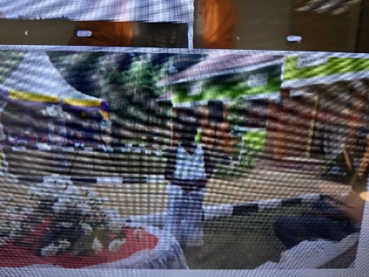The learning practitioner holding a book. 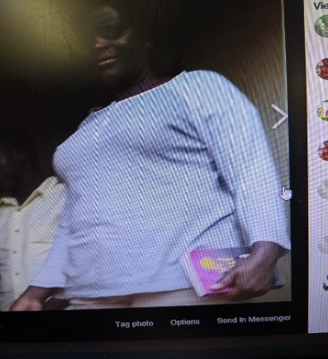
- The report is written for the attention of the family centre manager. In definition, a family centre is a place that provides local support to parents, carers, and children.
- They often offer a range of targeted services across health, parenting, childcare and community learning to support diverse family needs. It’s the Website project family located at Kanziira.
  - Brief outline of the setting, the activities and services
- The website project family – Kanziira is having the reputation of serving the Young people particularly the children, babies, parenting sessions, teenager or youth involvement as well as keeping the home generally.
- Home people serves or deserves a key aspect in relation to the monitoring, inspecting, governing, leading as well maintenance following it’s reputation.
- The services at the family with children observes maximum discipline, socialisations, entertainments, conversations, and understanding the principle of welcoming people at the home. That states that with no reasonable doubt, a visitor at the home can be welcomed where attention and observations to or for such can be tailored well with greetings and giving a seat.
- Back to the gist of the family, learning is one of the major aspect that requires a directorate’s signposting as well as managing risk can include positive risk gain. For instance, from the risk benefits assessment, an assessment prior to the commencement of any welcome or the resume of the day’s work requires to be undertaken.
- From the module material, Butler (2016) identifies on the play safety forum with the theme of play work risk benefit assessment. Parents have to be with the Children.
- Risk assessment before entry on the premises requires to be undertaken. The children set a scare chase play that injured a child’s finger. Later, a court session was launched against the host Hackney play association. The claimant withdrew from the proceedings of the case because of the accusation of having no assessment before the children’s scare chase play from the premise.
- Remember, they had went through the assessment before entering the premise. That implies that the website project family – Kanziira does a great deal with visitor welcoming hosts as well as managing the family well whilst overseeing such effects that Hackney play association manifested. The Manager and the general team works well to with standards that are required following the health, learning standards as well as safety.
- The Henry programme supports the health, exercise, nutrition for the real young, young children with families under five, aims to form a child’s habits and parents being the receptive of support with breastfeeding support as well as building a relationship with other families.
- Parent (s) happy to share a snap with the child that includes the child’s wellbeing to include good healthier lives. Kanziira health centre NHS) offers heath inspections to the family as Lesley from the module material.
- Dynamic strength-based assessment tool that gives out the kind of safety that requires to be developed whilst using a relationship approach that is grounded, safety organised approach to child protection, practice and created through the research of what works for Professionals and families in building a meaningful safety or vulnerable and at-risk Children such as Ethen with the organisation of the party backed by activity 6.9 signs of safety from the module material. Turnell (1990’s) in Western Australia points out working on children and their families with jurisdiction from America, Colombia extra with the view of caring and protecting them.
- A select of one of the activities or services from the brief outline
  - The learning service opportunity being offered at the Website project family – Kanziira. From the module material, my world: ecological assessment with Bronfenbrenner (1979 and 1995) links the pedagogy of being able to communicate, enjoying family and friends, becoming independent and looking after thyself, being health, learning and achieving as well as being or developed to being confident in who I am. The opportunity given out gives the participants the truth about learning. Because they learn, and engage in a variety of services that are offered at or from Website project family – Kanziira inspiring educational grounds. Earlier from the report about, mentions Syden whilst appreciating the home’s learning atmosphere as well as getting involved in the family’s learning services such as greeting, conversations, partying and taking snaps. This rewards Syden cognitively where Syden’s behaviourism becomes well modelled, shaped, appreciated as well as being confirmed as the very best Child for Website project family – Kanziira.
  - Literally, the open University (2021) offers a course that links well with the joys of project family, where learning is a key theme. Activity 5.3 recalls shaping learning by roles, parents, friends, teachers, teaching Assistants and youth workers. In connection to the website project family-Kanziira, it is believed that the place is well facilitated with the opportunities that relates to learning such as greeting, conversations, play and extra. Hence, ensuring the safety of the family and it’s surbodinates includes Syden as a learner. More that, activity 5.6 making a difference with supporting children’s learning and how staff evaluates the effectiveness, calls for an example where of Millie having left two Schools because of her educational learning with behaviour, Millie had to join the bridge. Millie was welcomed at the Bridge infact, the behaviour was believed to be okay. It was only because Mille’s was an adolescent whose behaviour was matched well with the available opportunities such as having trips, engaging in play with the rest of the class as well as attending the given apportionments. In connection to the website project family Kanziira, Syden as a learner is enjoying the learning as well as managing herself well. In evaluations, the parents and the team are offering a great opportunity to the upbringing of the girl. The conduct is superb hence, well structured management is sidelining Syden from experiencing what Millie experienced.
  - Furthermore, activity 1.13, that relates to the wellbeing, data collection and the family’s learning achievement are measured while using the Parents, the child and the participation. And so, the sharing of the knowledge of the current research, theory and policy with other people including who learns and work in particular settings are clear. Therefore, activity 6.4 shapes the idea that allows calculations about risk and learning as well as skills development in the future. As Victoria (2019) laments from the book chapter, practices in the sense of reflection, shared objectives and social interaction, requires an emphasis on the importance of learning to enable people share in a common life. In a glance, learning can be defined as the process of acquiring the knowledge that requires participation whilst getting the needed people skills such as greeting, conversations extra that can enable the children get the skills for their development and getting work.
  - From the international perspective, learning about Child protection as well as keeping them from was once championed by Turnell (1990’s). Worked on the dynamic strength-based assessment tool that gives out the kind of safety that requires to be developed whilst using a relationship approach that is grounded, safety organised approach to child protection, practice and created through the research of what works for Professionals and families in building a meaningful safety or vulnerable and at-risk Children such as Ethen with the organisation of the party backed by activity 6.9 signs of safety from the module material. Turnell (1990’s) in Western Australia points out working on children and their families with jurisdiction from America, Colombia extra with the view of caring and protecting them. And so, learning and positive risk taking requires an assessment that can underpin any shortcoming.
  - It is important to note the learning that can be got from Lesley’s visitation. (The Open University, 2021) - Activity 4.5) Lesley a health visitor from the module material organised a learning trip to a family that was met to build a parental – child relationship in terms of child rearing, parenting, giving an advice on the available benefits, as well as carrying out an assessment. The lessons from that includes building a relationship between a child and the parent ofcourse as well as the staff. Advising on nutrition for the benefit of having a healthier child. The Website project family – Kanziira connects Kanziira health service (NHS) for the general health advice, as well as maintaining a Professional relationship with the family. Hence, support skills, knowledge and professionalism.

  - A select of the second activity / service from the brief outline
  - It is the positive risk taking activity that is linked to music play as well as organising a party. It was in particular organised by the assistant manager for the party a 15 year old Ethen. View the image below attached. Ethen is in the red strip from the left hand side. Is pretty a young thoughtful teenager with the idea of organising the party occasion.
  - 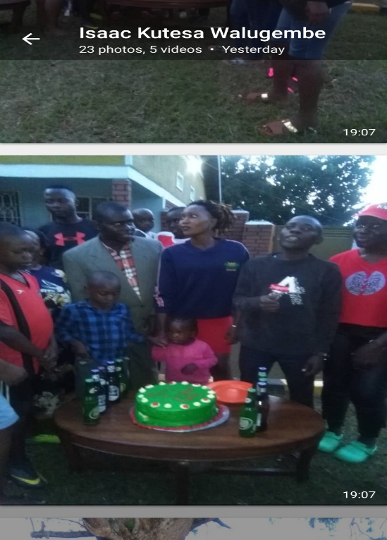
- One of the pictured is the Assistant Manager Ethen for the party who was happy to record the occasion. The positive risk taking was backed by his dears Parents, uncles, aunties and friends. A few of the items according to the nutritional diet included a cake and soft drinks. That makes a glance to what the Henry programme embraces whilst exercising acceptable health, exercise, nutrition for the real young (HENRY) programme from the module material. The Parents expects Ethen to be a creative lovely dearest Child as well as being able in managing situations.
- The benefit from that opportunity was creating a lovely rapport between his family and friends. It was happily finished not as what the children with the chase play at or from Hackney play association resulted into while injuring a finger (Butler, 2016).
- Party Video in action - Positive risk taking by Ethen Assistant Manager
- Ethen Positive risk taking – party - Principalquarters for website: Xmas(2020) Prince Samuel Kyagera (online) available at http://www.buteeradisan.wordpress.com
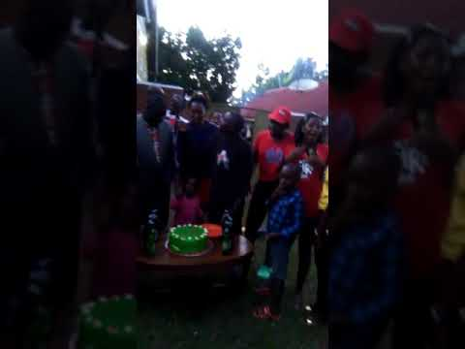
- The party was once again meeting the positive risk-taking responsibility. The music play was well played that caused an excitement from the crowd. The Children and young people were invited to the front. The learning from positive risk taking involves getting the team skill, socialisation, understanding the purpose of the occasion as well as keeping the confidence. The Assistant manager was confident as well as managing the situation. The party cost in pounds £350.00. The soft drinks included juice and the cake.
- Remember Megan from the module material (The Open University, activity 6.4) cites a BBC television series – child of our time that is reading about a birthday party celebration at 16 whilst mirroring the changing minds. She prepared cola diet, friends to bring own alcohol, high seat protected whilst being fenced around the room with a white cloth. The idea was drinking and exploring alcohol drinking with friends.
- Megan’s mother, alcohol was under supervision to control the excitement and anxiety. Megan’s parents as of Ethen encouraged Megan to always to do as well as counting money. Hence, maintaing safety, risk and taking of responsibility. Megan organised a DJ, made a cake as well as enjoying the pop music playing during the party night.
- The positive risk taking for Megan resulted into entertaining the friends as well as the family. Learning to take risks was still a major effect on Megan. That is linked to the use of alcohol as well as dancing during the night. Infact, water to dilute the alcohol was used because teen behaviour instincts would begin with a lesser amount of toxication.
- During the placement at Website project family -Kanziira, there has been an inspiration mostly from our Assistant manager Ethen a 15 year old. The party attracted Website project family – Kanziira to include the learning practitioner, Syden extra. Infact, from the appendices, the senior management was with the learning practitioner, parent and the child. That was demonstrating a comfortable baby skill relationship.
- The opportunity with the placement, has been working on Youth Justice cases that calls for court intervention, youth offending sessions accompanying as well as sitting on Kanziira Local Authority’s benches whilst working on children, teenagers, and the youth. Rewards includes the party above, food, drinks, accommodation, transport, as well as pocket money from Website project family -Kanziira as an appreciation for participation and attendance.
    - Conclusion of the matter
- In the closing remarks, the report is about a bid for funding that the manager has to submit for funding. The effective use of learning and positive risk taking also have been manifested with the report whilst citing out examples such as Syden, Ethen, Megan as well as the Hackney play association. That is indicating that learning and positive risk taking requires to be carefully attended. In doing that, the website project family – Kanziira has to make it clear that the learning process environment is okay as well as being well facilitated.
- During the course of the activities, risk benefit assessment as well as the initial assessment before the use of any service, requires to be undertaken. Syden and the learning practitioner are showing a good example with learning. The chase play by children from hackney play association carelessly injured a finger. This report was carefully assessed by and fully supervised. As a result of the matter, success was amongst the most important achievement.
- From the appendices, the Assistant Manager Ethen was sitting from the Home Office family – Kanziira whilst holding a dairy. With positive risk taking, Ethen’s parents expected creativity as well as managing situations. The party finished happily.
    - Word count (2500 words)
- References
- Butler, N. (2016) ‘A small but potentially significant win for risk–benefit assessment’, Play Safety Forum [Online]. Available at https://playsafetyforum.wordpress.com/casestudies/
- The Open University (2021) ‘ 3 Educational opportunities – Activity 5.7 Millie’s story’ (online) available at https://learn2.open.ac.uk/mod/oucontent/view.php?id=1646931&section=5 Last Accessed on 22/02/2021
- Turnell, A. (1990’s)’Signs of safety’ (online) available at http://www.signsofsafety.net
- Willis et al (2016) in the open University (2019) the practice example, Henry, Children and young people’s wellbeing KE206 Making a difference: Working with Children and young people, The open University, pp.109.
- Victoria, C (2019) ' what is meant by learning and why is it so important?’ Children and young people’s wellbeing: KE206 Making a difference: Working with Children and young people; The Open University, pp. 128 – 129.
- Willis et al (2016) in the open University (2019) the practice example, Henry, Children and young people’s wellbeing KE206 Making a difference: Working with Children and young people, The open University, pp.109.
- The Open University (2021) ‘KE206 Topic 4: Health – Practice example: HENRY’ The Open University
- The Open University (2021) ‘ KE206 Topic 4: Health: Activity 4.5 working with families to support mental health’ (online) available at Topic 4: Health: 3.1 Infant mental health (open.ac.uk)
- The Open University (2021) ‘KE206 Safety, Topic 6 Activity 6.4, safety, risk and responsibility' (online) available at https://learn2.open.ac.uk/mod/oucontent/view.php?id=1646932&amp;printable=1&section=4.1#t6_a4 Last Accessed on 23/02/2021
- Appendices picture showing Syden whilst appreciating the home environment as a young learner and other very important persons in connection to the family centre – Website project family, Kanziira in connection to the module activity requirements
- 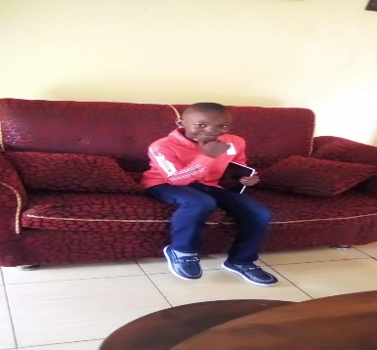Ethen the Assistant party Manager holding a dairy at The Home Office family – Kanziira.
- 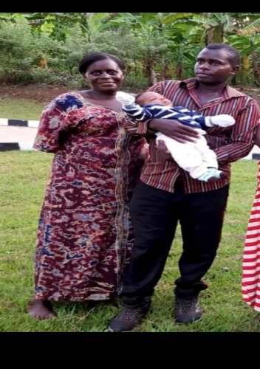
- Senior Management family with Parent – Child comfort skill demostration.
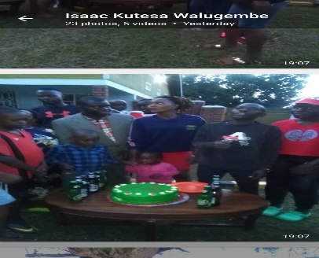
- Assistant manager Ethen with the team.
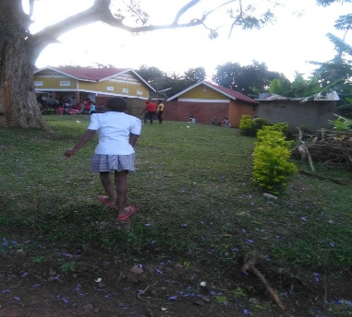
- Grounds of the family

