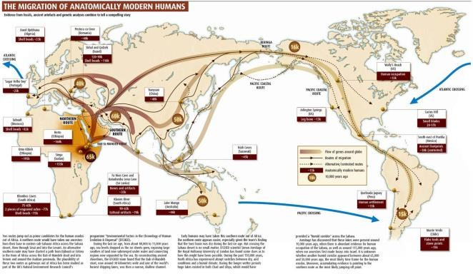
Family
Website

(
Url) is
Http://www.buteeradisan.wordpress.co
m

Management and Administration
Team

Disan Buteera

Mairane

–

Director & Project Manager

1

1

[
Date
]

Central Home Office is based at Kanziira, Mairane Avenue, The Home Office Nobility Royalty, Gomba District, Ug

