Module 100500 - The National Curriculum and Effective Teaching Methods

The National Curriculum
‘The national curriculum provides pupils with an introduction to the essential knowledge that they need to be educated citizens. It introduces pupils to the best that has been thought and said; and helps engender an appreciation of human creativity and achievement.
The national curriculum provides an outline of core knowledge around which teachers can develop exciting and stimulating lessons to promote the development of pupils’ knowledge, understanding and skills as part of the wider school curriculum’.
Department of Education, The National Curriculum in England Framework Document July 2013
For the table of the Key Stages in Primary School and Secondary School refer to the downloaded handout for this session (these and further tables/information can be found at www.education.gov.uk).

The National Curriculum - Context
- All subjects have a curriculum
- Core Subjects; Maths, Science and English
- Foundation Subjects; Art & Design, Citizenship, Design & Technology, Geography, History, Information & Communication Technology (ICT), Music & PE.
- Both core and foundation subjects must be taught within schools

Refer to the Handout for a table/ diagram of what subjects have to be taught to which Key Stage (the table of this information can also be found at www.education.gov.uk )

Attainment Levels
- Attainment Levels outline the knowledge, skills and understanding which pupils are expected to acquire within the National Curriculum by the end of each Key Stage.
- There are eight level descriptions (levels) of increasing difficulty plus a description for exceptional performance above level 8. Some schools have adapted sub- levels, so teachers have flexibility to plan and assess pupils learning as shown in the diagram.
- Each level is split into sub-levels that are like the old grade system with ‘a’ as the best, ‘b’ in the middle and ‘c’ toward the bottom of that level. So a 5a is better than a 5c, and a 5c is better than a 4a.
- The other thing to note is that the levels are the same throughout infant, primary, junior, and secondary school (and are used right up to year 9, before switching to GCSE’s). This means that someone on a 3a in year 9 should theoretically have the same ability as someone on a 3a in year 2!
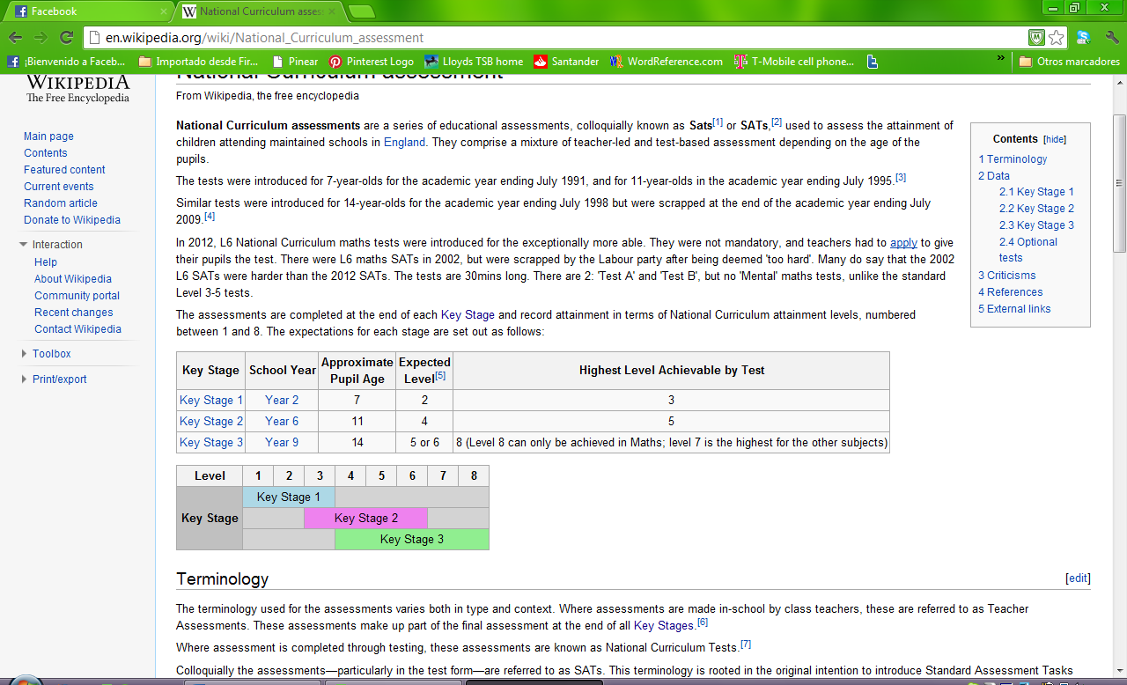
For example by the end of Key Stage 1 (Year 2 of Primary School) all pupils are expected to reach at least Attainment Level 2.
(For a clear table/description of this information go to www.education.gov.uk )

Early Years Foundation Stage
- Emphasis is on ‘play’.
- Learning through play.
- Preparation for school.
- Laying the foundations of learning.
- Commitment to fulfilling the five strands of the ‘Every Child Matters’ (ECM) Agenda.

Key Stage 1
- Includes Years 1 and 2.
- Pupils have to follow 10 statutory areas of the curriculum. These areas include, English, Maths, Science, ICT, Citizenship, Design & Technology, History, Geography, Art and Design, Music, PE.
- English, Maths and Science are classified as Core Subjects. All other subjects are classed as foundation subjects.
- Assessment occurs at the end of the Key Stage in Year 2. Teachers use in-house test to assess each Childs progress.
- The LEA (Local Education Authority) conducts moderation exercises to ensure consistency, and standardisation and equality across the tests.
- By the end of KS1 students are expected to reach Level 2 across the Core Subjects.

Key Stage 2
- Includes Years 3,4, 5 and 6.
- Similar to Key Stage 1, pupils have to follow the three core subjects of English, Maths and Science together with the other eight foundation subjects.
- Assessment occurs at the end of the Key Stage in Year 6. Most schools use Standard Assessment Tests (SATs) within the Core Subjects to assess the progress made within Key Stage 2. However, some schools similar to the Key Stage 1 rely on Teacher Assessment only.
- By the end of KS2 students are expected to reach Level 4 across the Core Subjects.

Key Stage 3
- Includes Years 7,8 and 9.
- Similar to Key Stages 1 and 2, pupils have to follow the three core subjects of English, Maths and Science together with the other eight foundation subjects.
- Modern Foreign Languages (MFL) is also introduced as a foundation subject at the start of the Key Stage, with most schools opting for French. In some schools the more able students also begin to study German/Spanish at the start of Year 8 to accompany this.
- Assessment occurs at the end of the Key Stage in Year 9. Following the abolishment of the Key Stage 3 SATs and similar to the Key Stage 1, assessment is based on Teacher Assessment across all eleven subjects.
- By the end of KS3 students are expected to reach Level 5 across all subjects.

Key Stage 4
- Includes Years 10 and 11.
- Statutory subjects are reduced to English, Maths and Science, Citizenship, ICT and PE.
- This is to give students more individual choice and the opportunity to specialise.
- Assessment mainly occurs at the end of the Key Stage in Year 11, where students take GCSE exams.
- However some GCSE are becoming more modular and with vocational qualifications such as BTECs, there is also an on-going assessment component for most students.
- By the end of KS4 students are expected to achieve at least five GCSE’s A*-C including English and Maths.

Key Stage 5
- Includes Years 12 and 13.
- No statutory subjects; allows students to specialise and choose a career direction.
- Students can study for academic qualifications such as AS / A Levels, or vocational qualifications such as Diplomas/ Level 3 BTECs.
- Students can also combine academic qualifications with vocational study to choose a pathway which is right for the individual.
- Most of these qualifications carry UCAS points which help get students into university or higher education.

Assessment at Key Stage 5
- Assessment for academic subjects is modular and occurs mainly through exams during Years 12 and 13 when modules have been completed.
- Assessment for vocational subjects is on-going and coursework based which relieves the pressure of exams.
- By the end of KS5 students will need sufficient UCAS points to pursue a course which they wish at university of a Higher Education Institute.

The English Baccalaureate
- The English Baccalaureate also known as ‘the EBAC’ was introduced by the Government in 2010.
- It is a performance indicator that measures the percentage of students in a school who achieve grades A*-C in English, Mathematics, two Sciences, a Foreign language and History or Geography.
- It is not a standalone qualification, (children do not sit exams for the EBAC) but it is awarded to those students who achieve a certain number of GCSEs in particular subjects, as outlined above.
- Introduced to address the shortage of linguists and those studying traditional subjects.
- Is now included as a measure for school league tables, which has prompted schools to adapt the pathways which students can follow.

Vocational Study
- Vocational training focuses on practical applications of skills learned.
- It is a ‘hands on’ way of learning.
- It provides the link between education and the working world.
- Vocational study is available in a wide range of subjects such as Hair & Beauty, Science, Engineering and Sport and Leisure.
- Awards are at different levels of Diplomas and BTECs. ; e.g. Level 1, Level 2, Level 3 and provide GCSE/A-Level equivalents.

Effective Teaching is:-
- Devised to achieve particular learning outcomes.
- Allows all students to make good progress.
- Take into account the needs, aptitudes and abilities of the specific group of pupils for whom they are planned.
- Differentiation enables pupils across the ability range to achieve their potential.

What is a Teaching Strategy?
A teaching strategy is...
“A general term used to describe the cluster of methods employed by teachers to ensure that pupils learn”.

Teacher-Led Teaching Strategies
- Purpose; Role of the learner is perform - following the teachers decisions.
- Examples of teacher-led strategies include exposition, command and direct teaching.
- The main reasons for using a teacher led-strategy are that:-
  - They save time.
  - They allow the teacher to retain good classroom control/behaviour management.
  - They allow teachers to ensure safety when they are teaching topics that have an element of risk/danger.
- However, teacher-led strategies have some major weaknesses such as:-
  - Learning being too passive.
  - The limited attention-span of the learner.
  - What is said is not always what is heard.
- As a result student-led approaches should be utilised where possible.

Student-Led Teaching Strategies
- Purpose: to create memorable learning experiences by actively engaging learners within their learning.
- Examples of student-led strategies include Discussion, Reciprocal teaching Guided Discovery and Learner Initiated Teaching.
- The main reasons for using a student led- teaching strategy are that:-
  - Learning is active so students are more likely to retain information.
  - It allows learners to develop creative solutions to the problems presented.
  - It replaces the notion that the leader must know all the answers.
  - It allows learners to develop a wide range of key skills that employers value.
- However, student-led strategies also have some weakness if not implemented properly which include:-
  - Learning becoming unfocused and moving away from objectives.
  - Student-led approaches are more time consuming than teacher-led .
  - If student-led teacher strategies are not managed effectively they could allow the student to ‘coast’.

What is Differentiation?
Differentiation is...
‘A complex notion related to the ways in which teachers provide for variations in the interests, aptitudes and abilities of children.’
A.Caborn / V.Gordon 1995

Why Differentiation is Required?
- Classes have different skills and ability levels.
- Classes have different levels of cognitive understanding.
- Classes have different levels of academic understanding.
- Classes differ in factors such as self esteem, socio-cultural and economic backgrounds.

Strategies to Achieve Differentiation
Think about the:
- Task – What changes do we make for the different levels of understanding in the class?
- Strategy – How much control do we want and how much do we let the students have?
- Outcome – What do we want the students to know/ be able to do at the end of the lesson?

Differentiation by Task
- Setting different tasks with the same learning outcomes.
- Making the same task simpler or more difficult.
- Using different resources to aid pupil learning, including teaching aids, information, published resources and worksheets.
- Explaining the task in more child friendly language.
- Allowing students to complete a task in a way that accommodates their learning style/way of working.

Differentiation by Strategy
- Considering the ability of your pupils to make decisions and the level of control you wish to have.
- Individual/Pair/Group working.
- Modifying the resources/support available to complete the task.
- Utilising differentiated worksheets to allow the lower ability to make progress.
- Utilising a Teaching Assistant with those groups who require additional help.
- Allowing students to complete a task in a way that accommodates their learning style/way of working.

Differentiation by Outcome
- Different end results: e.g. number of sentences/maths problems etc...
- Different types of response; e.g. Quality/depth – standard of grammar/ relevance of the information etc...

Top Tips
- Familiarise yourself with the National Curriculum for the Key Stage that you want to teach.
- Use exemplar material to aid lesson planning – borrow examples from other teachers/ websites.
- When planning consider each class on an individual basis.
- Recognise that teaching is no longer about ‘chalk and talk’ and learning being solely teacher-led.
- Utilise more student-led teaching approaches where possible; OFSTED want to see this!
- Utilise DIFFERENTIATION.

Useful websites
- Access to the National Curriculum in England http://www.education.gov.uk/schools/teachingandlearning/curriculum
- Resources on Differentiation http://teachertools.org/?page=differentiationClassRoom
- http://www.tes.co.uk (you will need to register on this site to access some of the information – it is free to register)
- http://www.sitesforteachers.com this site has various resources/information that you might find useful
- http://www.educationscotland.gov.uk for an idea of the Scottish education system
- http://www.senteacher.co.uk this site has various teacher support and resources/information regarding differentiation and Learning Difficulties
- http://www.edexcel.com/btecinschools
- http://www.teachhub.com/student-led-instruction-strategies

