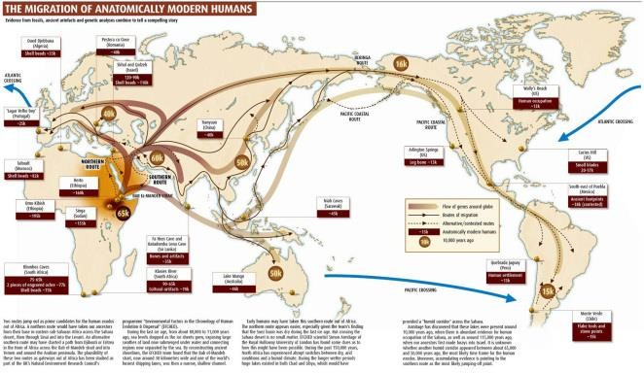
Family
Website

(
Url) is
Http://www.buteeradisan.wordpress.co
m

Management and Administration
Team

Disan Buteera

Mairane

–

Director & Project Manager

1

1

[
Date
]

Central Home Office is based at Kanziira, Mairane Avenue, The Home Office Nobilty Royalty, Gomba District, Ug

Letter of Consideration for a Volunteer Service
To Whom It Concerns
Subject: Mr. Disan Buteera
This is to confirm that Mr. Disan Buteera has been considered for the position of Web Administrator, Editor and Developer for Website Project Family – Buteera (online) via http://www.buteeradisan.wordpress.com for 2 hours a week for a period of a year. However, there’s no payment apart from gaining the skills and expertism. Starts on 01/05/2019 ends on 01/05/2020.
Thank you
Disan Buteera, Director and Project Manager

